Test Case: tc002_SPX_Dev5_Crear_Requisicion_Spot_Con_FAD_Tipo_Cobro_CC
Step 1 - Enter username and password and click to button Enter : Credentials Entered
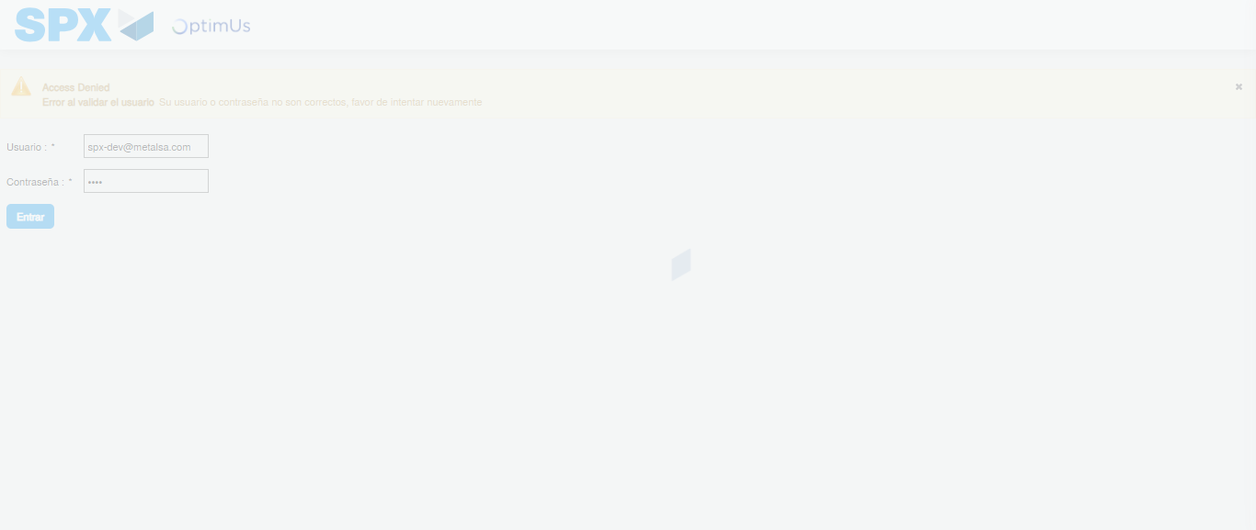Image file-name: QC_Testing-tc002_SPX_Dev5_Crear_Requisicion_Spot_Con_FAD_Tipo_Cobro_CC-1783355752781

Step 2 - Select to UEN and Access to Spot Buy Requisitions : UEN Correctly selected and Correct access
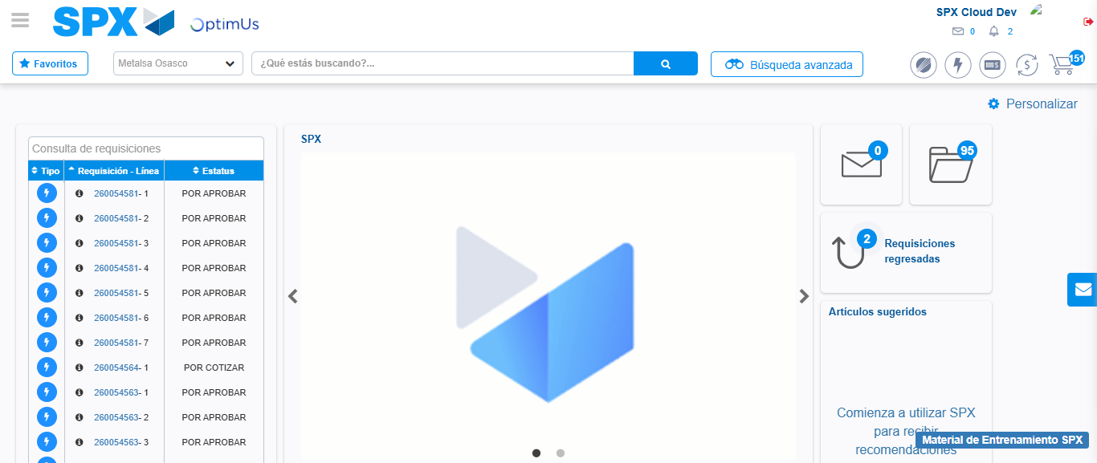Image file-name: QC_Testing-tc002_SPX_Dev5_Crear_Requisicion_Spot_Con_FAD_Tipo_Cobro_CC-1783355778303

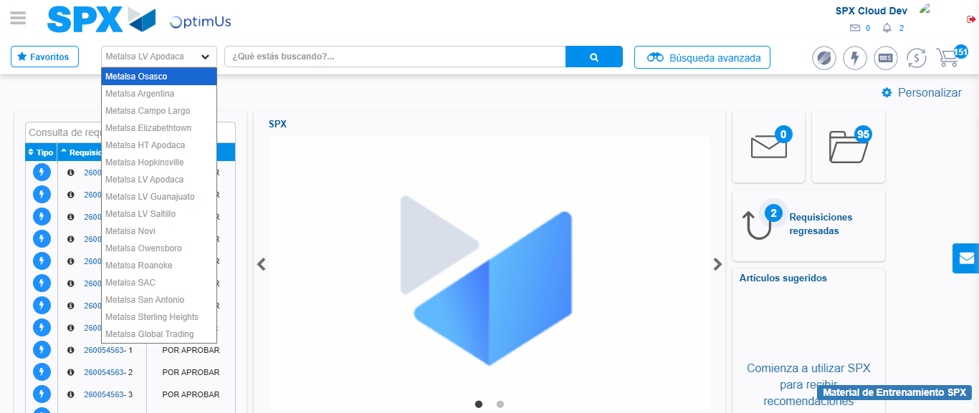Image file-name: QC_Testing-tc002_SPX_Dev5_Crear_Requisicion_Spot_Con_FAD_Tipo_Cobro_CC-1783355781202

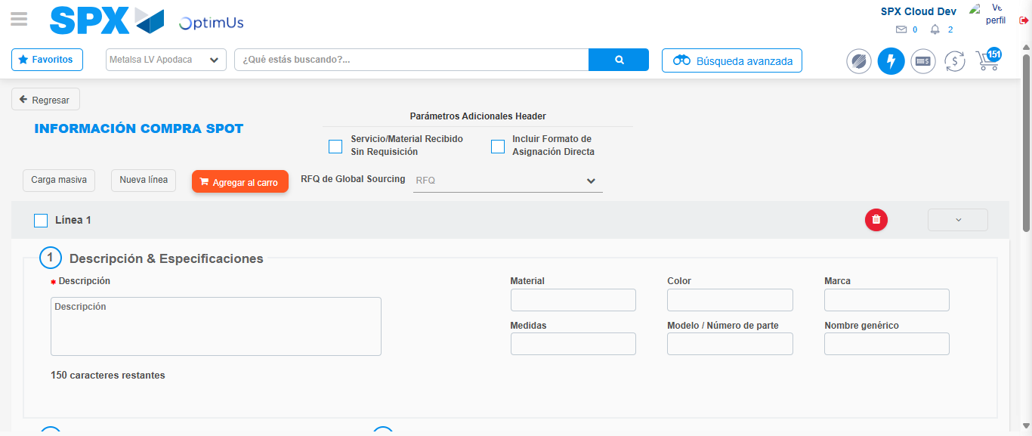Image file-name: QC_Testing-tc002_SPX_Dev5_Crear_Requisicion_Spot_Con_FAD_Tipo_Cobro_CC-1783355797757

Step 3 - Add FAD to Requisition: FAD Successfully Added
Image file-name: QC_Testing-tc002_SPX_Dev5_Crear_Requisicion_Spot_Con_FAD_Tipo_Cobro_CC-1783355798057

Image file-name: QC_Testing-tc002_SPX_Dev5_Crear_Requisicion_Spot_Con_FAD_Tipo_Cobro_CC-1783355798271

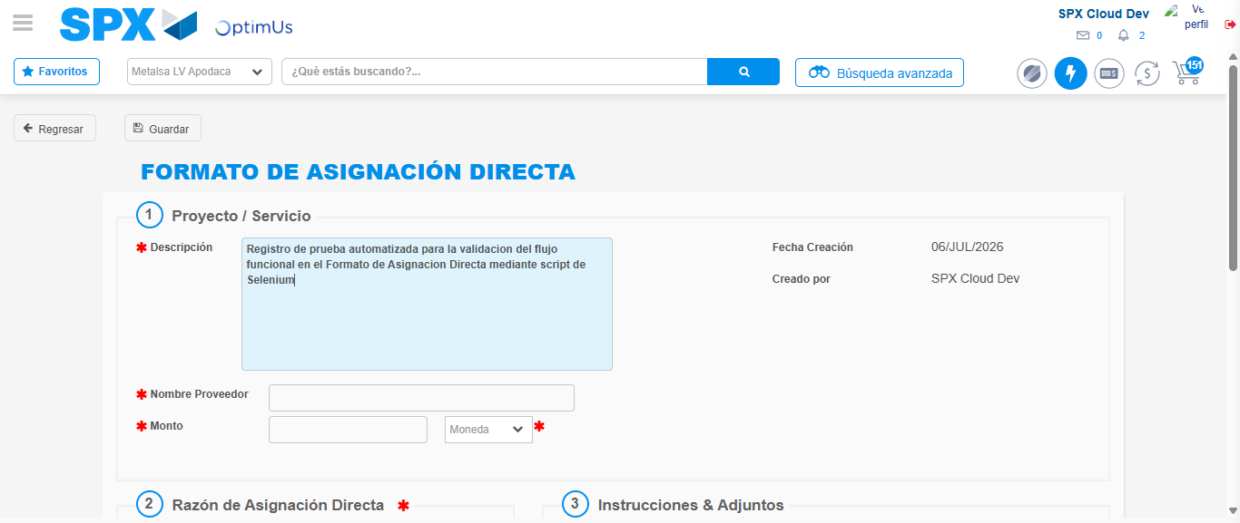Image file-name: QC_Testing-tc002_SPX_Dev5_Crear_Requisicion_Spot_Con_FAD_Tipo_Cobro_CC-1783355801313

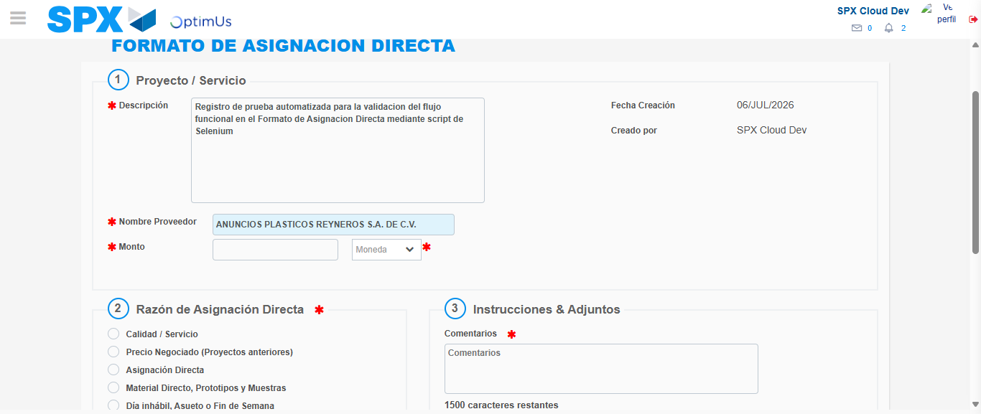Image file-name: QC_Testing-tc002_SPX_Dev5_Crear_Requisicion_Spot_Con_FAD_Tipo_Cobro_CC-1783355807982

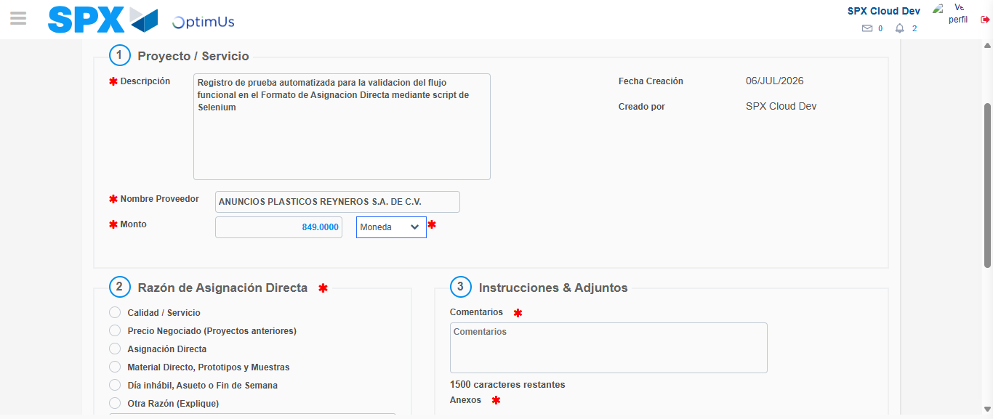Image file-name: QC_Testing-tc002_SPX_Dev5_Crear_Requisicion_Spot_Con_FAD_Tipo_Cobro_CC-1783355808502

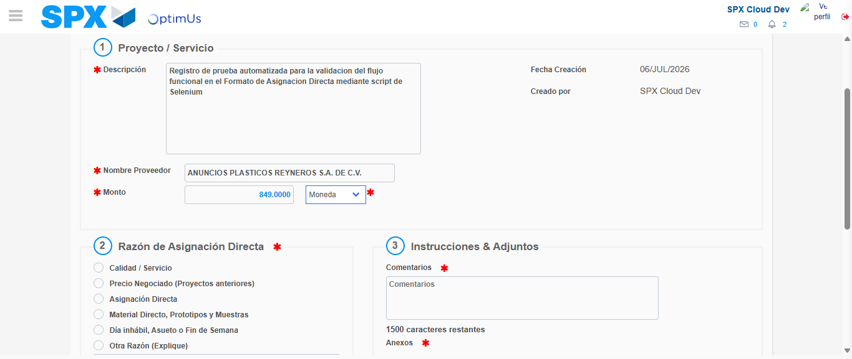Image file-name: QC_Testing-tc002_SPX_Dev5_Crear_Requisicion_Spot_Con_FAD_Tipo_Cobro_CC-1783355808770

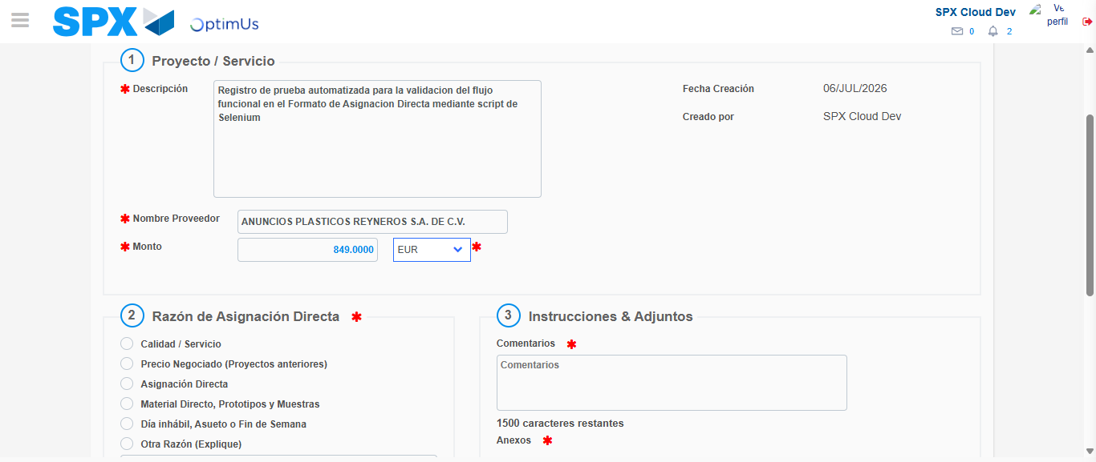Image file-name: QC_Testing-tc002_SPX_Dev5_Crear_Requisicion_Spot_Con_FAD_Tipo_Cobro_CC-1783355809232

Image file-name: QC_Testing-tc002_SPX_Dev5_Crear_Requisicion_Spot_Con_FAD_Tipo_Cobro_CC-1783355809457

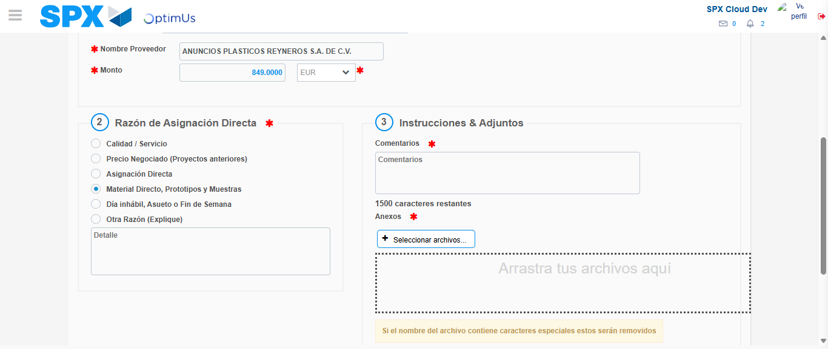Image file-name: QC_Testing-tc002_SPX_Dev5_Crear_Requisicion_Spot_Con_FAD_Tipo_Cobro_CC-1783355810385

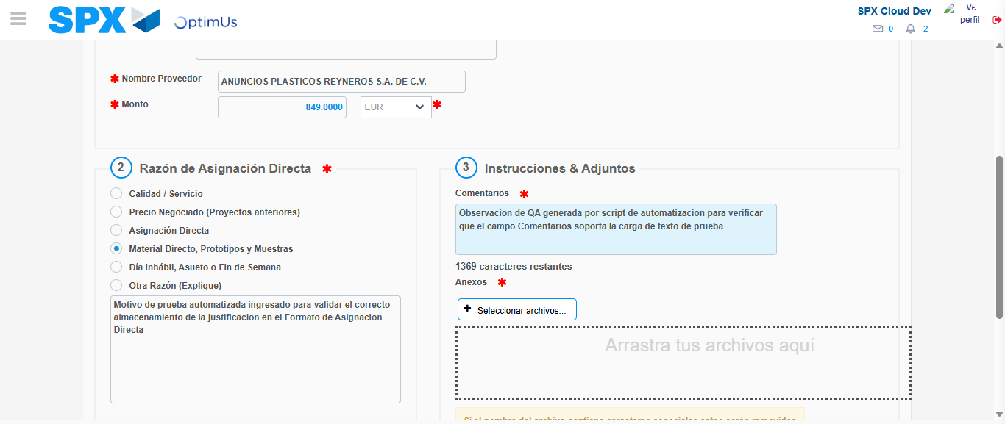Image file-name: QC_Testing-tc002_SPX_Dev5_Crear_Requisicion_Spot_Con_FAD_Tipo_Cobro_CC-1783355821800

Image file-name: QC_Testing-tc002_SPX_Dev5_Crear_Requisicion_Spot_Con_FAD_Tipo_Cobro_CC-1783355822733

Step 4 - Data Capture Spot Buy Requisition: Data captured correctly
Image file-name: QC_Testing-tc002_SPX_Dev5_Crear_Requisicion_Spot_Con_FAD_Tipo_Cobro_CC-1783355798057

Image file-name: QC_Testing-tc002_SPX_Dev5_Crear_Requisicion_Spot_Con_FAD_Tipo_Cobro_CC-1783355798271

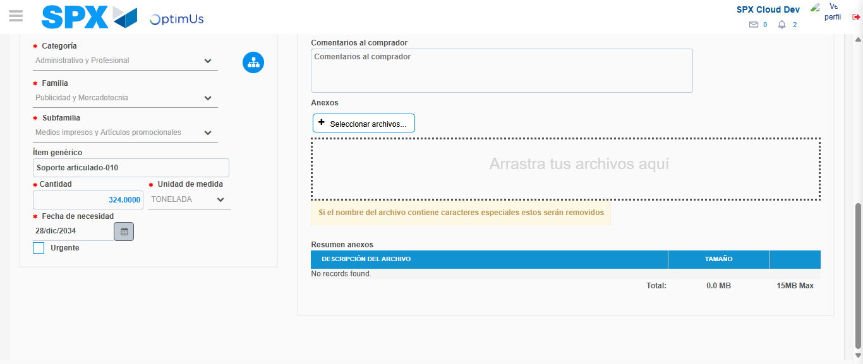Image file-name: QC_Testing-tc002_SPX_Dev5_Crear_Requisicion_Spot_Con_FAD_Tipo_Cobro_CC-1783355835303

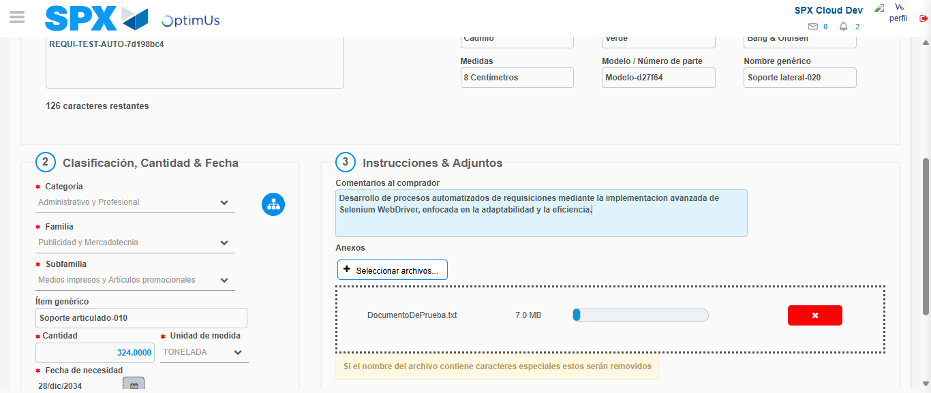Image file-name: QC_Testing-tc002_SPX_Dev5_Crear_Requisicion_Spot_Con_FAD_Tipo_Cobro_CC-1783355836094

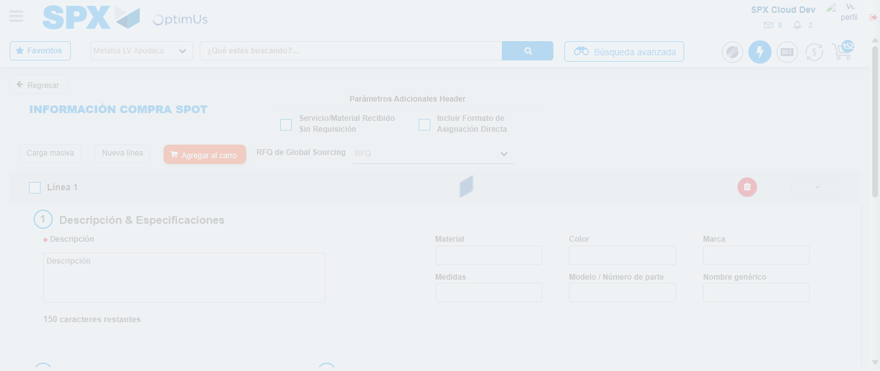Image file-name: QC_Testing-tc002_SPX_Dev5_Crear_Requisicion_Spot_Con_FAD_Tipo_Cobro_CC-1783355840150

Step 8 - Return to Main Page SPX : Return to Main Page SPX
Image file-name: QC_Testing-tc002_SPX_Dev5_Crear_Requisicion_Spot_Con_FAD_Tipo_Cobro_CC-1783355778303

Image file-name: QC_Testing-tc002_SPX_Dev5_Crear_Requisicion_Spot_Con_FAD_Tipo_Cobro_CC-1783355781202

Image file-name: QC_Testing-tc002_SPX_Dev5_Crear_Requisicion_Spot_Con_FAD_Tipo_Cobro_CC-1783355797757

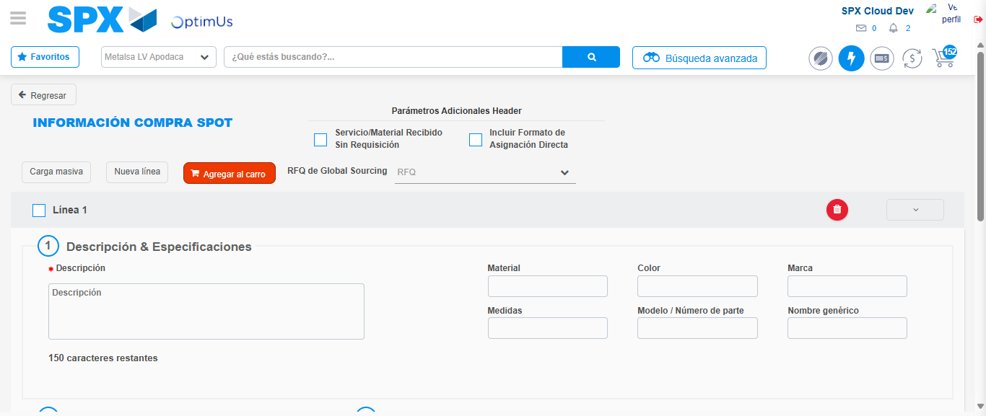Image file-name: QC_Testing-tc002_SPX_Dev5_Crear_Requisicion_Spot_Con_FAD_Tipo_Cobro_CC-1783355842357

Image file-name: QC_Testing-tc002_SPX_Dev5_Crear_Requisicion_Spot_Con_FAD_Tipo_Cobro_CC-1783355842518

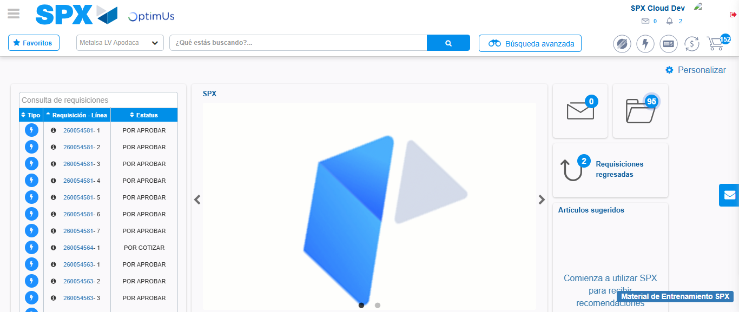Image file-name: QC_Testing-tc002_SPX_Dev5_Crear_Requisicion_Spot_Con_FAD_Tipo_Cobro_CC-1783355863534

Step 9 - Log Out : Log Out SPX
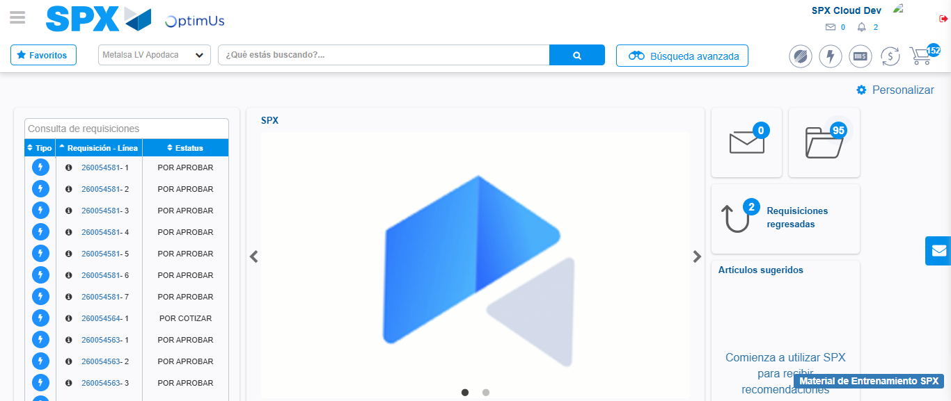Image file-name: QC_Testing-tc002_SPX_Dev5_Crear_Requisicion_Spot_Con_FAD_Tipo_Cobro_CC-1783355863824

